[[](https://yandex.ru/images/search?pos=4&img_url=https%3A%2F%2Fmyslide.ru%2Fdocuments_7%2F7463da417e94abd2a75d0e57b2cdd73c%2Fimg0.jpg&text=%D0%BB%D0%B5%D0%BA%D1%86%D0%B8%D1%8F+%D0%B4%D0%BB%D1%8F+%D1%80%D0%BE%D0%B4%D0%B8%D1%82%D0%B5%D0%BB%D0%B5%D0%B9+1+%D0%BA%D0%BB%D0%B0%D1%81%D1%81%D0%B0+%D0%BF%D0%BE+%D1%82%D0%B5%D0%BC%D0%B5+%D0%BE+%D0%B2%D0%B7%D0%B0%D0%B8%D0%BC%D0%BE%D0%BE%D1%82%D0%BD%D0%BE%D1%88%D0%B5%D0%BD%D0%B8%D1%8F%D1%85+%D0%B4%D0%B5%D0%B2%D0%BE%D1%87%D0%B5%D0%BA+%D0%B8+%D0%BC%D0%B0%D0%BB%D1%8C%D1%87%D0%B8%D0%BA%D0%BE%D0%B2&rpt=simage&lr=136741&source=wiz)](https://yandex.ru/images/search?pos=4&img_url=https%3A%2F%2Fmyslide.ru%2Fdocuments_7%2F7463da417e94abd2a75d0e57b2cdd73c%2Fimg0.jpg&text=%D0%BB%D0%B5%D0%BA%D1%86%D0%B8%D1%8F+%D0%B4%D0%BB%D1%8F+%D1%80%D0%BE%D0%B4%D0%B8%D1%82%D0%B5%D0%BB%D0%B5%D0%B9+1+%D0%BA%D0%BB%D0%B0%D1%81%D1%81%D0%B0+%D0%BF%D0%BE+%D1%82%D0%B5%D0%BC%D0%B5+%D0%BE+%D0%B2%D0%B7%D0%B0%D0%B8%D0%BC%D0%BE%D0%BE%D1%82%D0%BD%D0%BE%D1%88%D0%B5%D0%BD%D0%B8%D1%8F%D1%85+%D0%B4%D0%B5%D0%B2%D0%BE%D1%87%D0%B5%D0%BA+%D0%B8+%D0%BC%D0%B0%D0%BB%D1%8C%D1%87%D0%B8%D0%BA%D0%BE%D0%B2&rpt=simage&lr=136741&source=wiz)

[[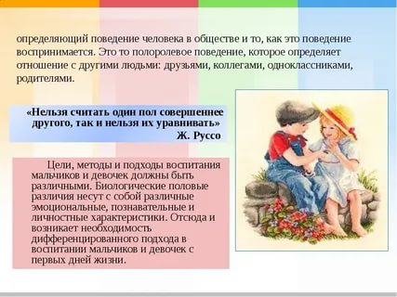](https://yandex.ru/images/search?pos=5&img_url=https%3A%2F%2Fds02.infourok.ru%2Fuploads%2Fex%2F0ae8%2F0000f547-5d022471%2Fimg6.jpg&text=%D0%BB%D0%B5%D0%BA%D1%86%D0%B8%D1%8F+%D0%B4%D0%BB%D1%8F+%D1%80%D0%BE%D0%B4%D0%B8%D1%82%D0%B5%D0%BB%D0%B5%D0%B9+1+%D0%BA%D0%BB%D0%B0%D1%81%D1%81%D0%B0+%D0%BF%D0%BE+%D1%82%D0%B5%D0%BC%D0%B5+%D0%BE+%D0%B2%D0%B7%D0%B0%D0%B8%D0%BC%D0%BE%D0%BE%D1%82%D0%BD%D0%BE%D1%88%D0%B5%D0%BD%D0%B8%D1%8F%D1%85+%D0%B4%D0%B5%D0%B2%D0%BE%D1%87%D0%B5%D0%BA+%D0%B8+%D0%BC%D0%B0%D0%BB%D1%8C%D1%87%D0%B8%D0%BA%D0%BE%D0%B2&rpt=simage&lr=136741&source=wiz)](https://yandex.ru/images/search?pos=5&img_url=https%3A%2F%2Fds02.infourok.ru%2Fuploads%2Fex%2F0ae8%2F0000f547-5d022471%2Fimg6.jpg&text=%D0%BB%D0%B5%D0%BA%D1%86%D0%B8%D1%8F+%D0%B4%D0%BB%D1%8F+%D1%80%D0%BE%D0%B4%D0%B8%D1%82%D0%B5%D0%BB%D0%B5%D0%B9+1+%D0%BA%D0%BB%D0%B0%D1%81%D1%81%D0%B0+%D0%BF%D0%BE+%D1%82%D0%B5%D0%BC%D0%B5+%D0%BE+%D0%B2%D0%B7%D0%B0%D0%B8%D0%BC%D0%BE%D0%BE%D1%82%D0%BD%D0%BE%D1%88%D0%B5%D0%BD%D0%B8%D1%8F%D1%85+%D0%B4%D0%B5%D0%B2%D0%BE%D1%87%D0%B5%D0%BA+%D0%B8+%D0%BC%D0%B0%D0%BB%D1%8C%D1%87%D0%B8%D0%BA%D0%BE%D0%B2&rpt=simage&lr=136741&source=wiz)

[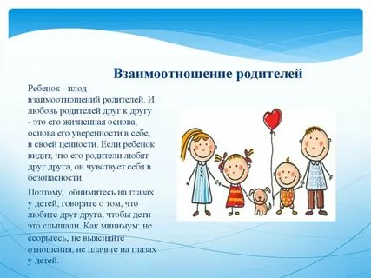](https://yandex.ru/images/search?pos=7&img_url=https%3A%2F%2Fcf2.ppt-online.org%2Ffiles2%2Fslide%2Fp%2FPKFEd9NZbh3HnILuYBQk67WJCmGAvVrqglXpctaDO8%2Fslide-11.jpg&text=%D0%BB%D0%B5%D0%BA%D1%86%D0%B8%D1%8F+%D0%B4%D0%BB%D1%8F+%D1%80%D0%BE%D0%B4%D0%B8%D1%82%D0%B5%D0%BB%D0%B5%D0%B9+1+%D0%BA%D0%BB%D0%B0%D1%81%D1%81%D0%B0+%D0%BF%D0%BE+%D1%82%D0%B5%D0%BC%D0%B5+%D0%BE+%D0%B2%D0%B7%D0%B0%D0%B8%D0%BC%D0%BE%D0%BE%D1%82%D0%BD%D0%BE%D1%88%D0%B5%D0%BD%D0%B8%D1%8F%D1%85+%D0%B4%D0%B5%D0%B2%D0%BE%D1%87%D0%B5%D0%BA+%D0%B8+%D0%BC%D0%B0%D0%BB%D1%8C%D1%87%D0%B8%D0%BA%D0%BE%D0%B2&rpt=simage&lr=136741&source=wiz)